Scneario 10 Evaluation for the samples .

**Moderate to Severe Evaluation**

Sample_id : DCPK7X

Cats and dogs:

Any two of the following:

(

High Red Flag Megamonas OR (failed)

High Red Flag Sutterella OR (failed)

High Red Flag Collinsella OR (failed)

Low Red Flag Bacteroides OR (passed)

Low Red Flag Blautia (failed)

);

OR

Dogs:

8 or more yellow flags; (failed)

OR 8 or more red flags; (failed)

High red megamonoas,suttrella,collinsella got failed.

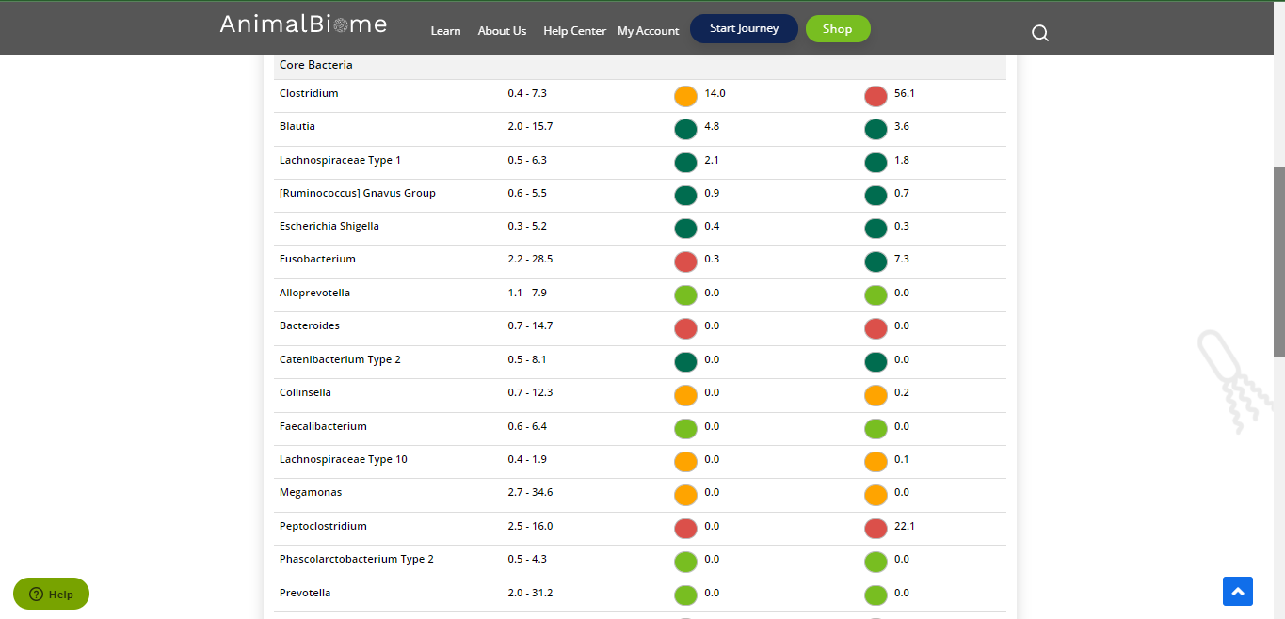

Low group evaluation .

low red blautia : failed.

Low red bacteriorides : passed. (only one satisfied ) in primary group.

Total yellow flags : 4

Red flags : 7

Moderate to severe evaulation result : failed.

**Mild to Moderate evaulation**

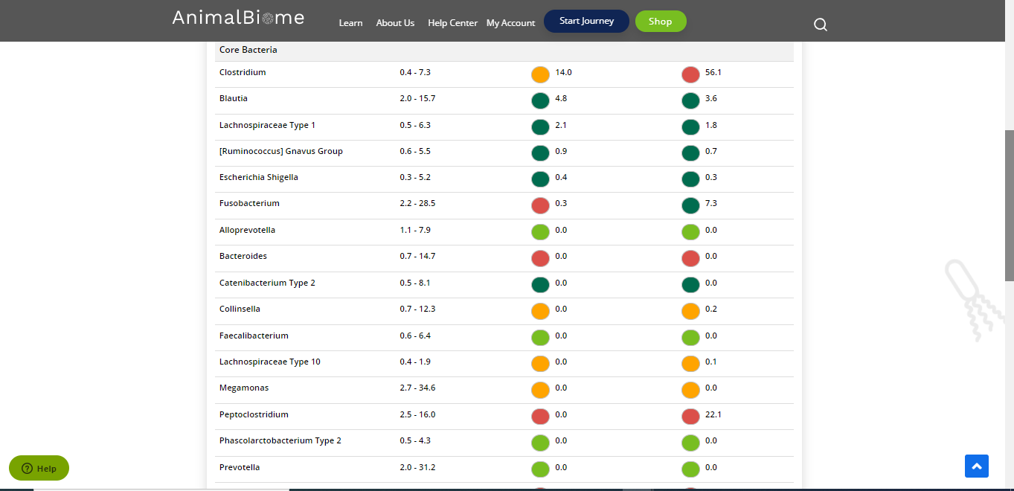

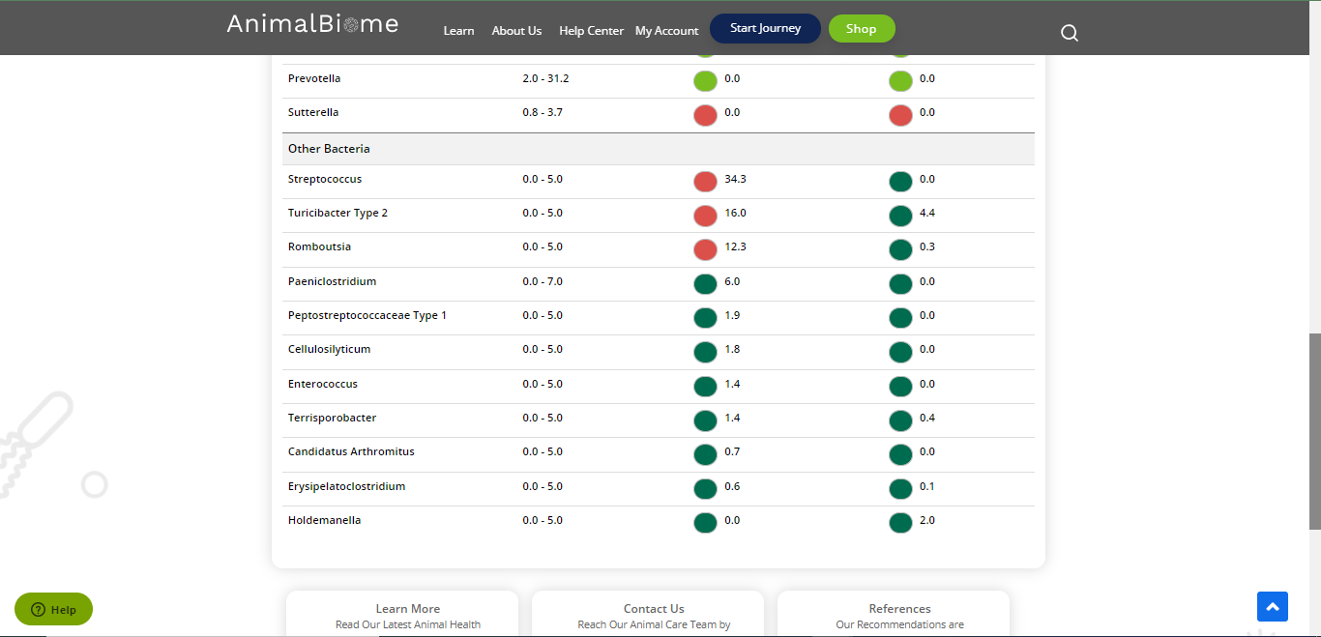

**Mild to Moderate**

Cats and dogs: Any Two  
(High Yellow Flag Megamonas OR (failed)  
High Yellow Flag Sutterella OR (failed)  
High Yellow Flag Collinsella OR (failed)  
Low Yellow Flag Bacteroides OR (failed)  
Low Yellow Flag Blautia (failed)  
)  
OR Dogs: 4-7 Yellow Flags (passed)  
OR 5-7 Red Flags; (passed)  
Cats: 8-10 Yellow Flags  
OR 5-8 Red Flags  
OR Cats and dogs: dietary recommendation of increase fiber or protein or decrease carbs. (passed)

The result : False True True True.

Expected result : Mild to moderate

Acheived result : passed.

